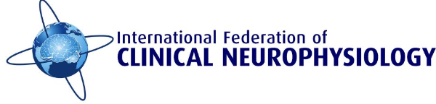

Europe-Middle East-Africa Chapter (EMEAC)

Quantitative EMG and Neuromuscular Ultrasonography Teaching Course

Application Form, 14-16, June 2024
All documents must be received no later than April 5th, 2024

Name:
Date of birth (dd/mm/yyyy):
Contact address:
City and zip code (post code):
Country:
e-mail:

I certify that, at the time of this application:
□ I am a member of my National Society for Clinical Neurophysiology

For the applicants who apply for a travel grant, I certify that,
□ I am from a low- or lower-middle-income country

---------------------------- ------------------------------------------
Date Signature

The goal of the Teaching Course Application
Short description of why and how the teaching course in this particular topic is relevant, how the course will result in change in the applicant’s current practice (max 250 words)

IMPORTANT: The application form must be accompanied by a structured CV and a copy of passport or other government-issued ID.
Applications should be sent to Antonin Gechev, antoningechev@yahoo.com and Hatice Tankisi, hatitank@rm.dk.
Applications must be typed, and not handwritten! All documents must be in the order listed above on 1 PDF file. Incomplete applications will not be accepted.

